**9.Perform time series analysis in Python.**

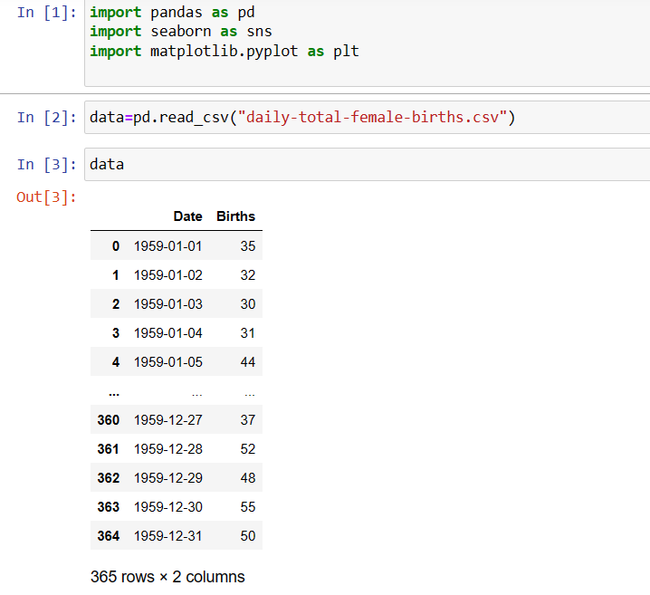

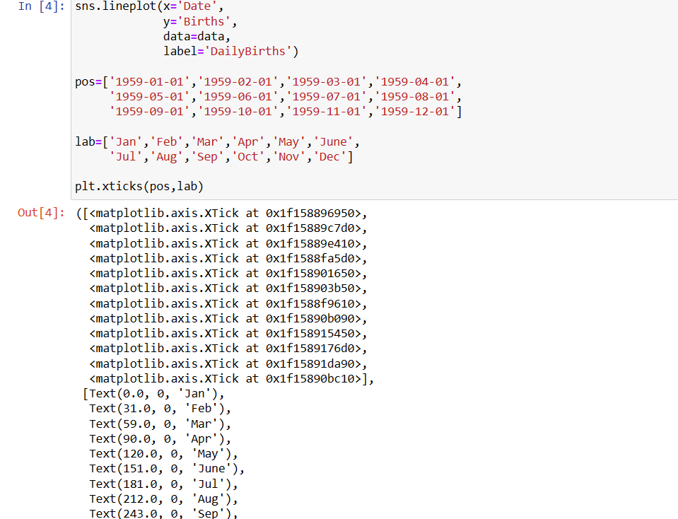

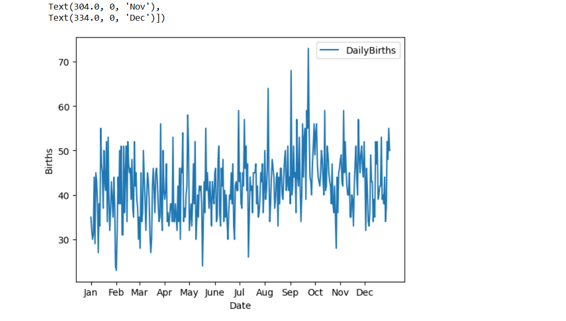

We can notice that it is very difficult to gain knowledge from the above plot as the data fluctuates a lot. So let us plot it again using Rolling Average concept this time.

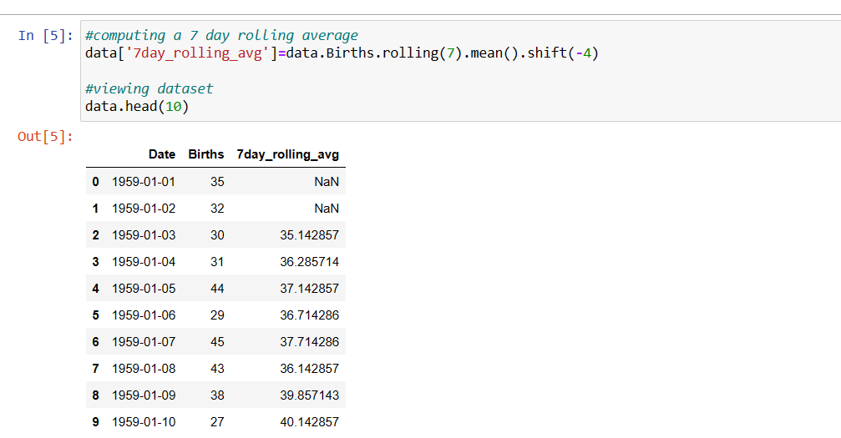

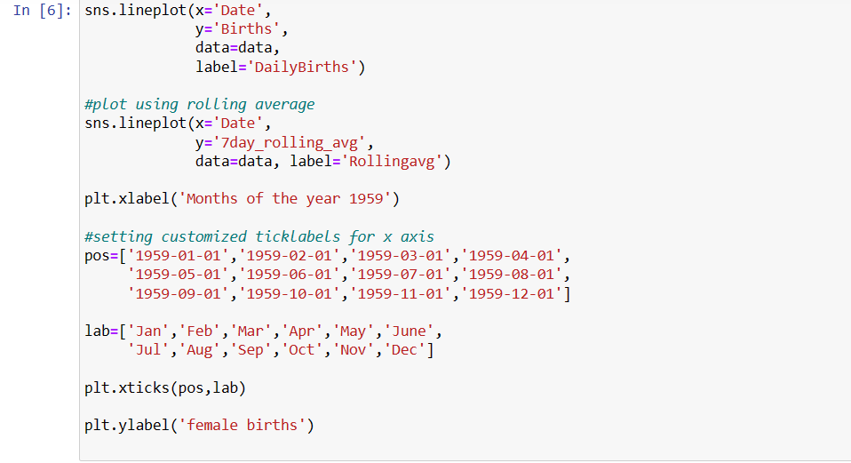

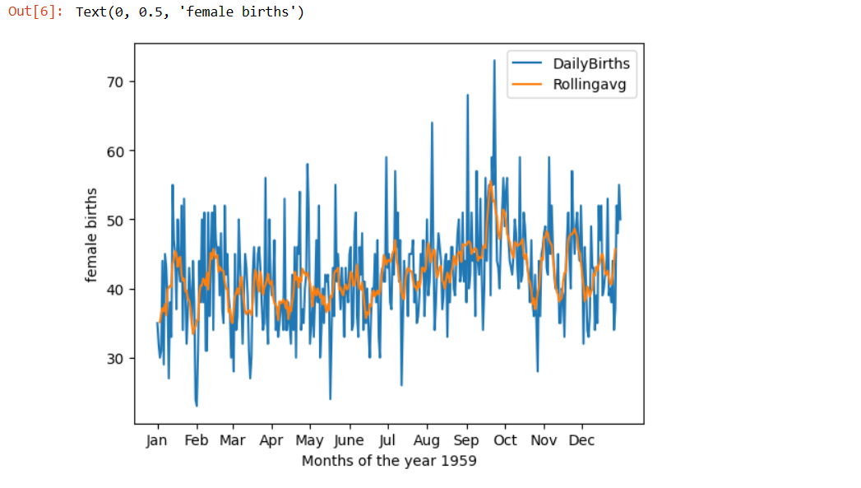

We can clearly see through the above graph that the rolling average has smoothened the number of female births, and we can notice the peak more evidently.